**1.React Todo List**

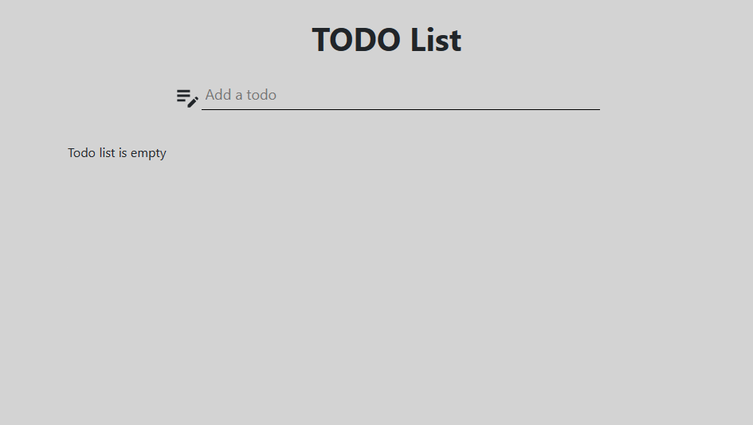

**Add task to to-do**

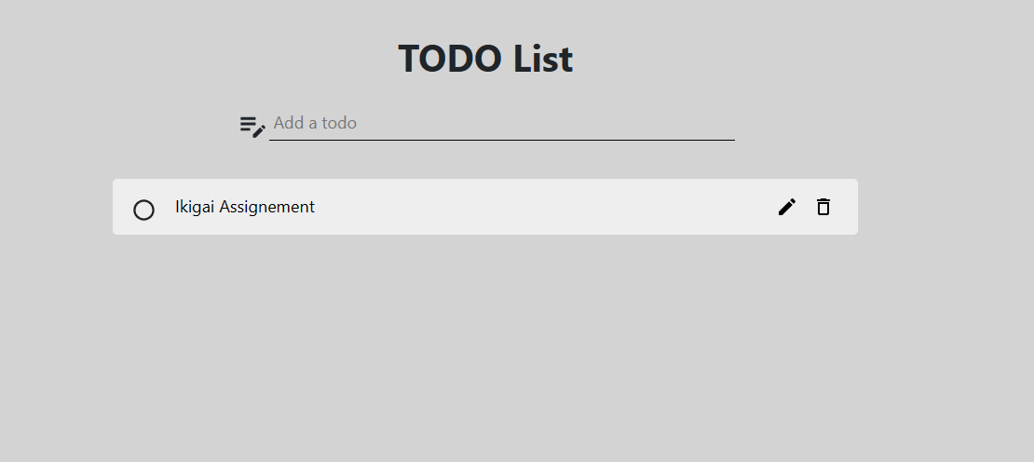

**Making the Task as completed**

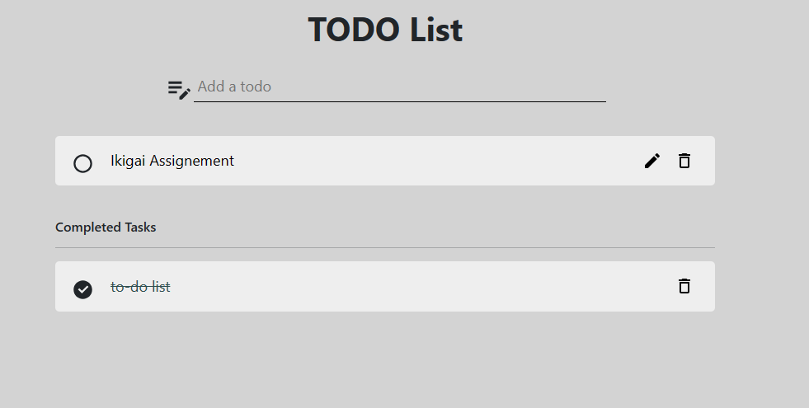

**Delete the Task**

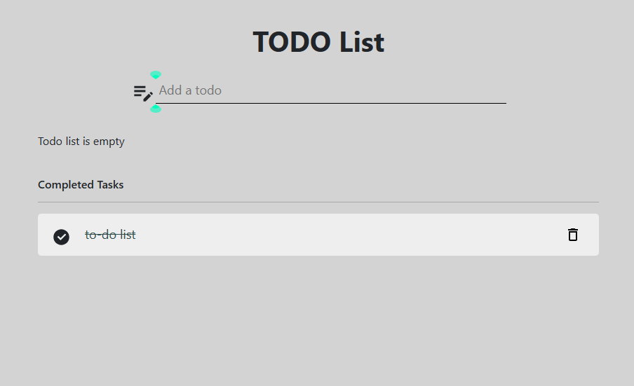

**Edit the task**

Earlier the task is this

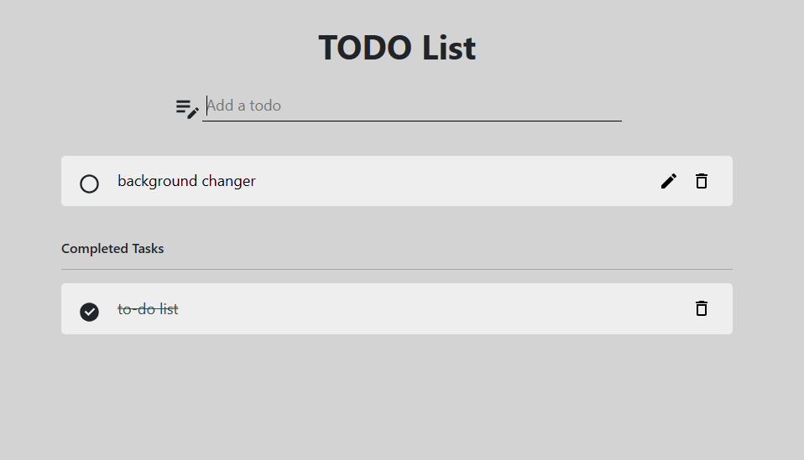

**After editing it looks like**

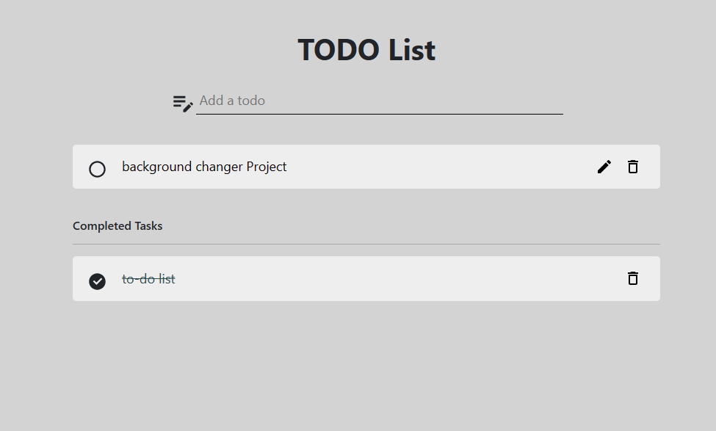

**2. Background changer Project**

We can change the color of the project we wish

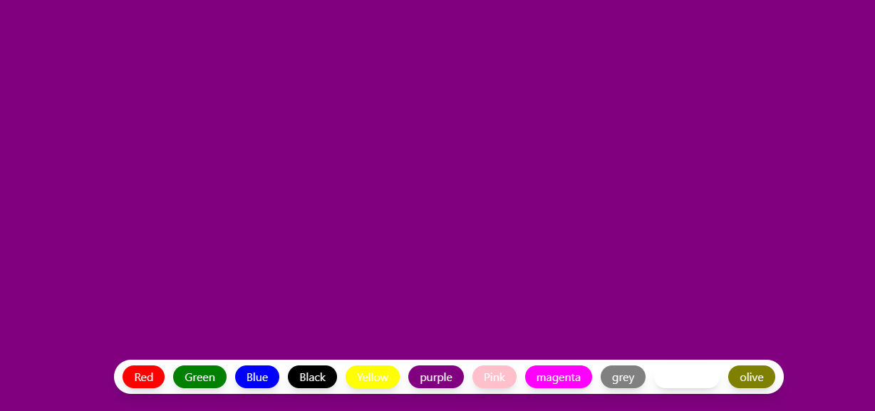

**If we refresh it the default color of the project is olive**

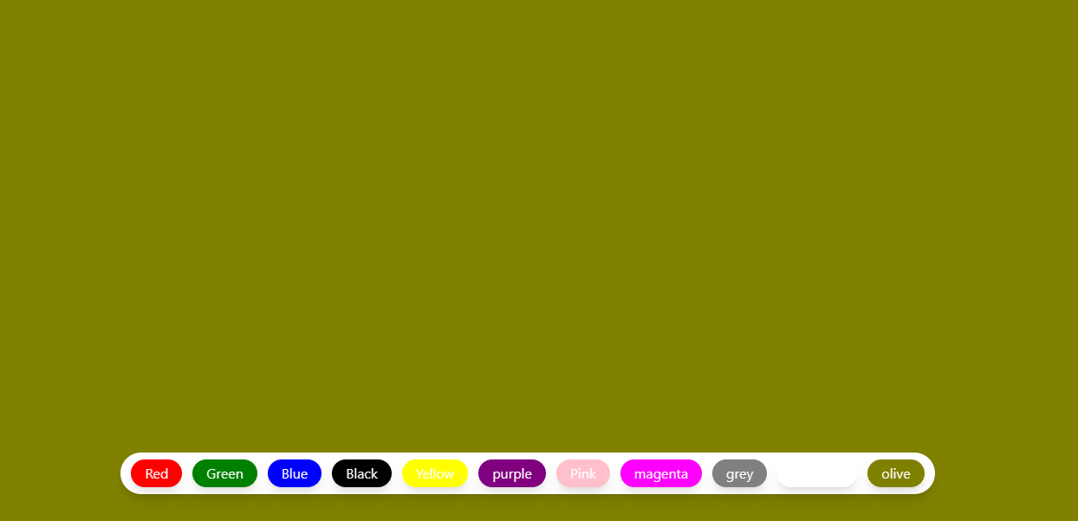

**3. Routing in React**

